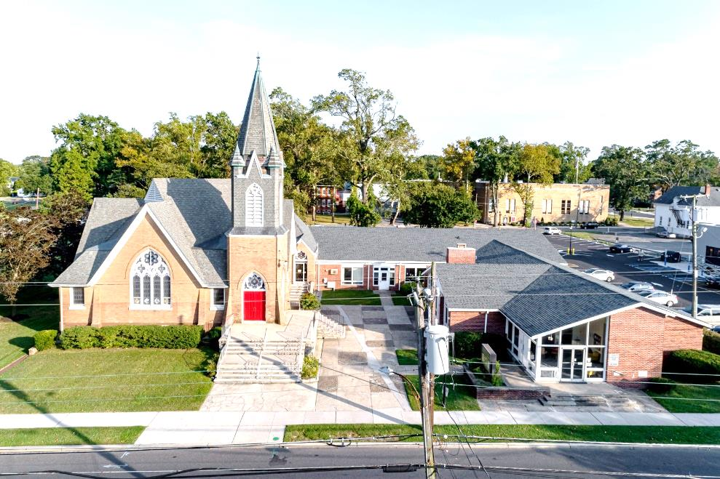

The Presbyterian Church at Hammonton
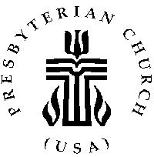

Our vision is to open our doors to all seeking a spiritual home of worship and to carry the light and love of Jesus Christ, our Savior, throughout the community.

MISSION STATEMENT
We are committed to Jesus Christ and the growing of his Church by glorifying God and by proclaiming the good news of the gospel through word and deed. We involve and reach out to our members and our community in Christ’s name through worship, Christian Education, and stewardship to support the mission of our church.

Note: Special thanks to Rev. Dr. Scott Morschauser for leading us in worship today.

Organist: Cindy Birnbaum
Sunday School Superintendent: Beth Burkett-Rice

2022 2023 2024
ELDERS
Eric Copenhaver Dorrine Esposito Sallye Hershman
Marylee Kondrach Richard Walker Paul Moul
Charles Muller Johanna Johnson

DEACONS
Elsie Bakley Wendy Copenhaver Hilda Lugo
Nancy Foster Ann DiMeo Carol Orsi
Margaret Jones Rebecca Lindstrom Rebecca Villani

Clerk of Session: Beth Burkett-Rice

Church Office: 326 Bellevue Avenue, Hammonton, NJ
Office hours: Tuesday - Thursday 9:30 AM to 12:30 PM
Phone (609) 561-0168 ~ Fax (609) 561-6105
e-mail: office@hammontonpres.org
website: www.hammontonpres.org

THE CELEBRATION OF WORSHIP
DECEMBER 18TH, 2022
4th SUNDAY OF ADVENT
VIRTUAL & LIVE SERVICE
11:00am
****************************************************
~ GATHERING IN GOD’S NAME ~
“Welcome to the Presbyterian Church at Hammonton, we are glad you are able to join us. As we gather for worship feel free to pray and meditate on God’s calling in your life. Be respectful of others around you who might be doing the same, prior and during the Prelude, keeping your voice and conversation soft and to a minimum.”
PRELUDE~ “A Star Over Bethlehem”-L. Smith
“Christmas Chimes”-D. Wells
“Little Drummer Boy” – Gospbell Ringers

~ TIME FOR CENTERING STILLNESS AND SILENCE ~

WELCOME AND ANNOUNCEMENTS

THE PEACE
Let the people greet one another by staying in their seats and saying: “Peace be with you!”

INTROIT
~ HUMBLY APPROACHING GOD ~

OPENING PRAYER

CALL TO WORSHIP
One: Rejoice in the Lord always, again, I will say rejoice!
All: May we let all people know our forbearance.
One: The Lord is near! Have no anxiety about anything!
All: But in everything, by prayer and supplication with thanksgiving, we will let our requests be made known to God.
One: The peace of God which passes all understanding will keep your hearts and minds in Christ Jesus.
All: And so we rejoice: the Lord is near! Let us now act according to His will!

*HYMN #54 ~ “From Heaven Above”

LIGHTING OF ADVENT CANDLES~ Lesley, Patti, &
Logan Langdon
CALL TO CONFESSION
The prophet Isaiah declares, "I will give thanks to you, O Lord, for though you were angry with me, your anger turned away, and you did comfort me." Trusting that God's forgiveness has been revealed to us in Jesus Christ, let us confess our sins before the Lord, first together as the church, then each of us in the silence of our hearts. Let us pray:

PRAYER OF CONFESSION (unison)
Almighty God: You have made us and all things to serve you. You have blessed us with the purpose of testifying to the world of your rule in Jesus Christ. Yet we have neglected our vocation, and often become the willing heralds of other kingdoms. Come quickly, to save us from temptation. Lead us to live by, and through your truth in Christ, and to give up the slogans and propaganda of the petty tyrants of the age. Bring us to a hopeful repentance this Advent season, so that we may trust that your kingdom has come, and does come in, and through, and as your dear son, and with him, we are privileged to be your sons and daughters, still and always. Amen. (silent confession)

ASSURANCE OF FORGIVENESS
Who shall separate us from the love of Christ? Shall persecution, or famine, or nakedness, or peril, or sword? No, in all these things we are conquerors through Him who loved us. For I am sure that nothing in all creation will be able to separate us from the Love of God in Christ Jesus, our Lord. I declare to you in his name: we are forgiven. Amen.
*GLORIA PATRI

ANTHEM~ “Mary, Did You Know?”

CHILDREN’S MESSAGE

~ RECEIVING GOD’S WORD ~

PRAYER OF ILLUMINATION

SCRIPTURE READINGS Luke 1:39-45 (NT pg 54)
Luke 1: 46-56 (NT pg 54)

MESSAGE ~ “Golden Oldies”
- Rev. Dr. Scott Morschauser

~ RESPONDING TO THE WORD ~

*HYMN #27 ~“Gentle Mary Laid Her Child”

*APOSTLES’ CREED (page 14)

JOYS AND CONCERNS OF THE CHURCH

PASTORAL PRAYER & LORD’S PRAYER
Our Father, who art in heaven, hallowed be Thy name. Thy kingdom come, thy will be done, on earth as it is in heaven. Give us this day our daily bread; and forgive our debts as we forgive our debtors; and lead us not into temptation, but deliver us from evil. For Thine is the kingdom and the power and the glory, forever. Amen.

THE OFFERING OF OUR GIFTS AND OURSELVES

OFFERTORY-“Christmas Carol Fantasy” -Gospbell Ringers

*DOXOLOGY (#592)
Praise God, from whom all blessings flow; Praise Him, all creatures here below; Praise Him above, ye heavenly host; Praise Father, Son, and Holy Ghost. Amen.

OFFERTORY PRAYER
O Lord, receive these our gifts as witnesses to the greatest gift-- our salvation in Jesus Christ. May we be useful in bearing witness to the Good News, and may each of us with thanks, receive our commission to be ambassadors of your reconciliation in Jesus' name. Amen.

~ GOING IN GOD’S NAME ~

*HYMN #41~ “O Come, All Ye Faithful”

*THE CHARGE AND BENEDICTION

POSTLUDE~ “An Acclamation of Joy”- D. Paxton

OUR WORSHIP HAS ENDED, LET OUR SERVICE BEGIN

*Signifies stand if comfortable.

Last Week’s Attendance & Offering:
Attendance: 56 people
Offering: $4,681.00

______________________________________________

CHURCH EVENTS

>>>THIS WEEK:

Monday-12/19:
9:00 AM Clothing Closet
-12:00 PM
7:30 PM ESL classes

Tuesday-12/20:
9:00 AM Clothing Closet
-12:00 PM

Wednesday-12/21:
9:00 AM Clothing Closet
-12:00 PM
7:30 PM ESL classes
______________________________________________

>>UPCOMING:

Monday-12/26:
7:30 PM ESL classes

Wednesday-12/28:
7:30 PM ESL classes

______________________________________________

BIRTHDAYS:

December 20 Kyle Hershman

______________________________________________

ANNIVERSARIES:

December 21 Darrell & Mary Hershman
December 24 Ed & Jennifer Clarke

SERVING YOU TODAY:

Liturgist: Rebecca Lindstrom

Ushers: Shawn Hershman, Captain
Al Brown
Donna Brown
Dorrine Esposito
Brenden Hershman
Sallye Hershman

**Children’s Church: Becky Villani
Next week: No Children’s Church

